

Announcement of Nonsung Police Station
Subject: Intention to not accept any kind of gifts from performing duties
(No Gift Policy)
*******************************************
Nonsung Police Station is determined to develop transparent operations adherence to common interests more than personal interests and without conflict of interest in accordance with the National Reform Plans on Prevention and Suppression of Corruption and Malfeasance (Revised Edition), which aims for agencies to operate with transparency, without conflict of interest. All government officials shall not accept any kind of gifts from performing duties. (No Gift Policy)
Therefore, we would like to announce the intention of the Commander of Nonsung Police Station and all police officers to not accept any kind of gifts while performing duties
(No Gift Policy). We will together establish organizational culture and integrity value at work, not accepting the patronage system, avoiding actions that may affect discretion or decision-making during performing duties that would lead to discrimination. Also, we cooperatively prevent the unfair performance of duties and a conflict of interest along with building public trust by performing our duties with good governance.
It is hereby announced and to strictly adhered to all.
This announcement is hereby issued on March 1st, 2025

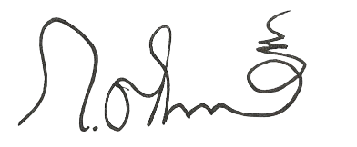

Police colonel
( Krittin Kopkumhiran )
Superintendent of Nonsung Provincial Police Station

